I B. Tech. I Semester Supplementary Examinations – December 2024

TECHNICAL ENGLISH COMMUNICATION
(BIOTECH/MECH)
Time: 150 Min Max. Marks: 60M

SECTION – A
Answer all Four question 4×8M=32M
- a) What is email etiquette?
b) Why is email etiquette important in day-to-day communication?
c) Write an email to your friend inviting him/her to your university function, where
you are going to receive an award. Give him/her some details about your award.

- a) What are cohesive devices?
b) Write a note on cohesive devices as navigators to the reader in a well written text
with suitable examples.
c) Write a paragraph describing an object which you use every day. Use all of the senses in your description, include a variety of adjectives to bring the paragraph to life for the reader.

- a) What are graphics materials?
b) List the various graphic aids used to present data.

c) Given below is a bar graph that shows the sales of books (in thousand number) from
six branches of a publishing company during two consecutive years 2020 and 2021.
Interpret the data in not more than 150-200 words. Sales of Books (in thousand
numbers) from Six Branches - B1, B2, B3, B4, B5 and B6 of a publishing Company in 2020 and 2021.
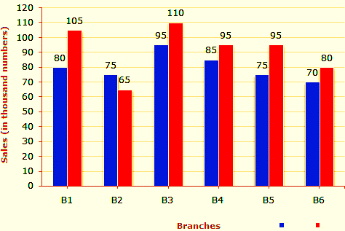
2021
2020

- a) What are the functions of business letter?
b) List out the characteristics of complaint letter?
c) You have purchased a laptop from an e-commerce website during a discount sale. However, you have received a laptop. The screen is broken and the battery appears to have been removed from the box. Write a complaint letter to the website asking for a replacement or refund.
SECTION - B
Answer all Two questions 2×14M=28M

- a) What is note making and why is it important?
b) Mention any four techniques of summarizing.
c) Read the following passage carefully and make a note on it, using headings and sub-
headings by giving an appropriate title. Also prepare the summary of it.

In a very short period of time the internet has had a profound impact on the way we live. Since the Internet was made operational in 1983, it has lowered both the costs of communication and the barriers to creative expression. It has challenged old business models and enabled new ones. It has provided access to information on a scale never before achievable.

It succeeded because we designed it to be flexible and open. These two features have allowed it to accommodate innovation without massive changes to its infrastructure. An open, borderless and standardized platform means that barriers to entry are low, competition is high, interoperability is assured and innovation is rapid. The beauty of an open platform is that there are no gatekeepers. For centuries, access to and creation of information was controlled by the few. The internet has changed that --and is rapidly becoming the platform for everyone, by everyone.

Of course, it still has a way to go. Today there are only about 2.3 billion internet users, representing roughly 30% of the world's population. Much of the information that they can access online is in English, but this is changing rapidly. The technological progress of the internet has also set social change in motion. As with other enabling inventions before it, from the telegraph to television, some will worry about the effects of broader access to information -- the printing press and the rise in literacy that it effected were, after all, long seen as destabilizing. Similar concerns about the internet are occasionally raised, but if we take a long view, I’m confident that its benefits far outweigh the discomforts of learning to integrate it into our lives. The internet and the world wide web are what they are because literally millions of people have made it so. It is a grand collaboration.

It would be foolish not to acknowledge that the openness of the internet has had a price. Security is an increasingly important issue and cannot be ignored. If there is an area of vital research and development for the internet, this is one of them. I am increasingly confident, however, that techniques and practices exist to make the internet safer and more secure while retaining its essentially open quality.

After working on the internet and its predecessors for over four decades, I'm more optimistic about its promise than I have ever been. We are all free to innovate on the net every day. The internet is a tool of the people, built by the people for the people and it must stay that way.

6. a) What is the style of report writing?
b) What are the characteristics of a good report?
c) Your University NSS team has participated in a web casting program as Community Service on the occasion of 18th Lok Sabha Elections. As the Chief Coordinator, write a report for your university newsletter VOICE in 150-200 words, with the help of the following cues:
Date and timings of the event -- equipment and technical preparation -- tasks and
expectations - dry run - quality and bit rate of the broadcast -- technical issues –
supporting media -- success criteria.

